
Pokhara University Faculty of
Management Studies

“CITY MED”
PROJECT REPORT

Submitted to
Anand Adhikari

Malpi International College

In partial fulfillment of the requirements for the Bachelor of Computer System and Information Technology.

Submitted by
Suraj Shrestha
Roll no
Sandesh Rai
Roll no
Omkar Ghimire
Roll no
Unique Acharya
Roll no

2026/08/23


Pokhara University Faculty of
Management Studies

SUPERVISOR’S RECOMMENDATION

I hereby recommend that this project prepared under my supervision by Put your Group members name here comma separated entitled “Project Name” in partial fulfillment of the requirements for the degree of Bachelor of Computer System and Information Technology is recommended for the final evaluation.

…………………………
Supervisor Name
Malpi International College
Narayangopal Chowk, Kathmandu


Pokhara University Faculty of
Management Studies

Malpi International College

LETTER OF APPROVAL

This is to certify that this project prepared by Your Group members name comma separated entitled “Project Name here” in partial fulfillment of the requirements for the degree of Bachelor of Computer System and Information Technology has been evaluated. In our opinion, it is satisfactory in the scope and quality of a project for the required degree.

Signature of Supervisor  ……………………  Supervisor Name  Project Supervisor  Malpi International College | Signature of Coordinator  …………………….  Coordinator Name  Program Coordinator  Malpi International College
Signature of Internal Examiner  ………………………  Internal Examiner | Signature of External Examiner  ……………………………….  External Examiner

ABSTRACT
The CityMed Hospital Management System is a web-based application built with PHP, MySQL, HTML, CSS, and JavaScript to digitize core hospital operations including appointment scheduling, prescription management, and patient record keeping. The system implements role-based access for two user types — doctors and patients — where doctors can manage appointments, write prescriptions, and update their profiles through a dedicated dashboard, while patients can register and log in to access hospital services. The database consists of four relational tables: users, appointments, prescriptions, and doctor_profile. The system replaces manual, paper based processes with a centralized digital platform, reducing administrative overhead and improving the quality of patient care.
Keywords: Hospital Management System, PHP, MySQL, Role-Based Access, Appointment Scheduling, Prescription Management.

ACKNOWLEDGMENT
We are obliged to several people who helped us to organize this project and are thankful for their kind opinions, suggestions, and appropriate guidelines. We have received endless support and guidance in finalizing our project so we would like to take this opportunity to thank them all.
First and foremost, we would like to express our special thanks of gratitude to our project supervisor [Supervisor Name] and to our project coordinator [Coordinator Name], who gave us the honor to do this wonderful project on the topic CityMed Hospital Management System, which has helped us a lot in sharpening our knowledge in web development, database design, and real-world software engineering. We are also thankful for their continuous feedback and encouragement throughout the project. Without their guidance, this project could not have been accomplished.
Secondly, we are overwhelmed with all the support and guidance from our parents and friends. They have assisted us occasionally in completing this project satisfactorily by giving innovative ideas and moral support throughout the development process.
We would also like to thank Malpi International College for providing us with the necessary resources, computing facilities, and the academic environment needed to complete this project. Finally, we extend our sincere gratitude to the Department of Bachelor of Computer System and Information Technology, Pokhara University, for accepting and supporting this project.

Suraj Maharjan
Sandesh Rai
Omkar Ghimire
Unique Acharya

(ADD)
LIST OF Abbrevation’
List OF TABLES
LIST OF FIGURES

CHAPTER 1: INTRODUCTION

Background of the Study
In today's rapidly evolving digital world, the healthcare sector is increasingly adopting information technology to improve the quality of medical services and simplify hospital operations. Traditional hospital management methods that rely on paper-based records, manual appointment scheduling, and physical prescription handling are no longer sufficient to meet the demands of modern healthcare. These conventional approaches often lead to misplaced records, scheduling conflicts, delays in treatment, and inefficient communication between doctors and patients.
The CityMed Hospital Management System was developed to address these challenges by providing a centralized, web-based platform that digitizes the core operations of a hospital. The system automates essential tasks such as appointment management, patient record maintenance, prescription handling, and profile management, making hospital services more efficient, organized, and reliable .The application is designed for two primary user roles: Doctors and Patients. Doctors can securely log into the system to manage online and manual appointments, write and update prescriptions, maintain patient records, and update their profiles. Patients can register, log in, book appointments, view appointment status, access prescriptions, and manage their personal information. The role-based access system ensures that users can only access features relevant to their responsibilities while maintaining data privacy and security.
The system is developed using PHP for server-side programming, MySQL for database management, and HTML, CSS, and JavaScript for creating a responsive and user-friendly interface. These technologies provide a reliable and efficient platform for developing a dynamic web application that can be accessed through modern web browsers .The CityMed Hospital Management System improves hospital administration by reducing paperwork, minimizing manual errors, and enhancing communication between doctors and patients. It demonstrates the practical implementation of web technologies and database management concepts in solving real-world healthcare challenges.This project was developed as a partial fulfillment of the requirements for the Bachelor of Computer System and Information Technology (BCSIT) degree at Malpi International College, affiliated with Pokhara University.

Statement of the Problem
Many hospitals, especially small and medium-sized institutions in Nepal, continue to rely on manual and paper-based processes for managing appointments, patient records, and prescriptions. This results in several problems:
- Appointments are difficult to track and often lead to overbooking or missed visits.
- Patient records are maintained on paper and are prone to loss, damage, or unauthorized access.
- Doctors spend significant time on administrative tasks rather than patient care.
- Prescriptions written by hand are often illegible and difficult to reference later.
- There is no centralized system where both doctors and patients can access relevant information securely.

Objectives of the study
The primary objectives of this project are:
- To develop a secure, web-based Hospital Management System using PHP, MySQL, HTML, CSS, and JavaScript.
- To implement a role-based authentication system that distinguishes between doctors and patients.
- To provide doctors with a dashboard to add, update, cancel, and delete appointments.
- To build a prescription module that allows doctors to create and update prescriptions linked to specific appointments.
- To maintain a patient records module where doctors can view patients associated with their appointments.
- To develop a public-facing hospital landing page that presents hospital services and enables user registration and login.
- To design a relational database with proper foreign key constraints that supports all system modules.
Together, these objectives aim to create a complete and secure digital solution for hospital operations. The system separates users by role so that doctors and patients only access relevant features, while the appointment, prescription, and patient records modules work together to streamline day-to-day clinical workflows. The public landing page makes the hospital accessible to new users through easy registration and login, and the underlying relational database — built with proper foreign key constraints — ensures that all this data stays consistent, accurate, and properly linked across modules.

Scope
The CityMed Hospital Management System includes the following features:
- Hospital Website and User Authentication: A public hospital website (index.php) with Home, About, Services, Doctors, and Contact pages, along with secure registration and login for both Doctors and Patients.
- Doctor Panel and Management Features: A Doctor Panel that includes appointment management (create, update status, and delete appointments), prescription writing and updating, patient record viewing, and doctor profile management, including specialization and password updates.
- System Scope and Limitations: The system is designed for offline use on a local XAMPP server and does not include online payment, video consultation, a mobile application, or a dedicated patient dashboard, making it suitable for academic and demonstration purposes.
The current version is designed for offline use on a local XAMPP server. It does not include online payment, video consultation, a mobile application, or a dedicated patient dashboard, making it suitable for demonstration and academic purposes.

Limitations of the study
While the CityMed Hospital Management System provides core HMS features, the following limitations apply:
- Limited Patient Features: Patients cannot book appointments online or access a dedicated dashboard to view their appointment history or prescriptions.
- No Advanced Communication or Payment: The system does not support online payment, real-time notifications, or messaging between doctors and patients.
- Local Deployment Only: The application is hosted locally using XAMPP and is not deployed on a live web server, limiting remote accessibility.
- Basic System Functionality: The current version focuses on essential hospital management features and does not include advanced functionalities found in commercial hospital management systems.
Despite these limitations, the CityMed Hospital Management System successfully demonstrates the core functionalities of a hospital management system and serves as a practical solution for academic learning and project demonstration.

CHAPTER 2: REVIEW OF LITERATURE

Theoretical Background
The CityMed Hospital Management System is grounded in several core concepts from software engineering and web application development. The system follows a client server architecture, where the client (browser) sends requests to a PHP-based server, which processes the logic, interacts with a MySQL database, and returns the appropriate response. This architectural model is widely used in web-based information systems because it separates concerns between the presentation layer and the data layer, making the system easier to maintain and extend.
Role-Based Access Control (RBAC) is another fundamental concept applied in this project. Users are assigned roles (doctor or patient) at registration, and the system restricts access to certain modules based on that role. This ensures that a patient cannot access a doctor's appointment dashboard, and a doctor cannot see the records of patients who are not assigned to them. RBAC is a standard security pattern in healthcare information systems.
The use of PHP's password_hash() and password_verify() functions ensures that user passwords are stored securely using bcrypt hashing, which is resistant to brute-force and rainbow table attacks. Session management with PHP sessions ensures that authenticated users remain logged in across pages, while session_start() and unset($_SESSION) handle login and logout flows securely.

Review of Related Projects
Several studies have explored the development of web-based Hospital Management Systems using PHP and MySQL to improve healthcare management. Earlier systems focused on patient registration, appointment scheduling, and maintaining centralized hospital records. Researchers also highlighted the importance of a centralized database for ensuring data consistency and reducing duplicate information. Other studies introduced role-based authentication, allowing doctors and patients to access only the features relevant to them, which improved security and usability. Prescription management modules were also developed to link prescriptions with specific appointments, increasing record accuracy and reducing medical errors. These research works demonstrate the importance of integrating multiple healthcare services into a single system. Based on these concepts, the CityMed Hospital Management System combines user authentication, appointment management, prescription writing, patient records, and doctor profile management in one platform with a simple and user-friendly interface, making it suitable for academic and demonstration purposes.

CHAPTER 3: SYSTEM DESIGN AND

TECHNOLOGY STACK

Technologies Used
Category | Technology | Purpose
Frontend | HTML5, CSS3, Bootstrap 5.3, Bootstrap Icons | Page structure, styling, and responsive layout
Backend | PHP 8 | Server-side logic, form handling session management
Database | MySQL (via mysqli, prepared statements) | Persistent storage for users, appointments, prescriptions
Server | Apache (via XAMPP) | Local development / hosting environment
Security | password_hash() / password_verify() (bcrypt) | Secure password storage and verification
Fonts/Icons | Google Fonts (Playfair Display, Inter), Bootstrap Icons | Visual design of the public-facing pages

Development Environment
- XAMPP (Apache + MySQL + PHP) for local hosting
- phpMyAdmin for database creation and management
- Modern web browser (e.g., Chrome, Firefox, or Edge) for running the system
- Code editor (e.g., Visual Studio Code) for PHP, HTML, CSS, and JavaScript development

System Architecture
The system follows a classic three-tier web architecture: the browser (presentation layer) sends HTTP requests to the Apache server, which runs the PHP application layer. The PHP layer is organized into an authentication module, a doctor panel, and patient-facing pages, all of which communicate with a single MySQL database using prepared statements via mySqli.

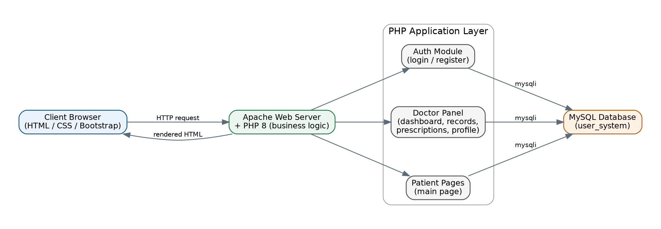
Figure -High-System architecture

Entity-Relationship Diagram
The database consists of four tables. The users table stores both doctors and patients, distinguished by a role column. Appointments and prescriptions are linked to the doctor who owns them via doctor_id, and a prescription is optionally linked to the appointment it was written for. Each doctor may have one doctor_profile record holding their specialization.
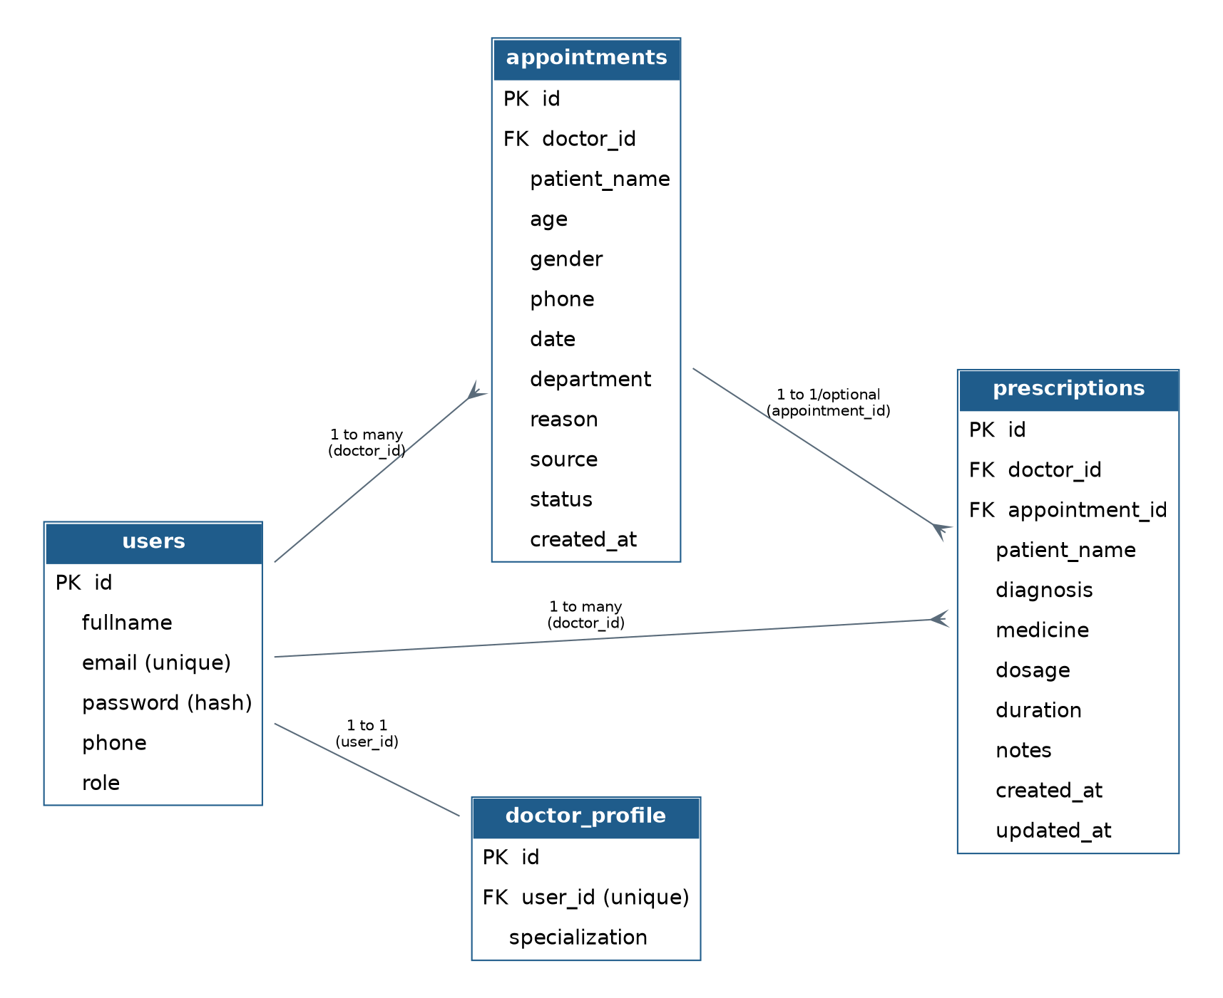
Fig Entity-Relationship diagram of the user_system database

Database Schema
Users — stores every registered account, doctor or patient.
Field | Type | Description
id | INT, PK, AUTO_INCREMENT | Unique user identifier
fullname | VARCHAR(100) | Full name of the user
email | VARCHAR(100), UNIQUE | Login email address
password | VARCHAR(255) | Bcrypt-hashed password
phone | VARCHAR(20) | Contact number
role | VARCHAR(20) | 'doctor' or 'patient'

Appointments — one row per booked appointment for a doctor.
Field | Type | Description
id | INT, PK, AUTO_INCREMENT | Unique appointment identifier
doctor_id | INT, FK → users.id | Doctor linked to the appointment
patient_name | VARCHAR(100) | Patient name
age | INT | Patient age
gender | VARCHAR(10) | Patient gender
phone | VARCHAR(20) | Patient phone number
date | DATE | Appointment date
department | VARCHAR(100) | Department or specialty
reason | VARCHAR(255) | Reason for visit
source | VARCHAR(20), default 'Manual' | Appointment source
status | VARCHAR(20), default 'Scheduled' | Status
created_at | TIMESTAMP | Record creation time

Prescriptions — diagnosis and medication details tied to an appointment.
Field | Type | Description
id | INT, PK, AUTO_INCREMENT | Unique prescription id
doctor_id | INT, FK → users.id | Doctor who wrote it
appointment_id | INT, FK → appointments.id | Related appointment
patient_name | VARCHAR(100) | Patient name
diagnosis | VARCHAR(255) | Doctor's diagnosis
medicine | TEXT | Medicine name
dosage | VARCHAR(50) | Dosage
duration | VARCHAR(50) | Duration
notes | TEXT | Additional notes
created_at / updated_at | TIMESTAMP | Record creation and last-update time

doctor_profile — extended profile information for doctors.
Field | Type | Description
id | INT, PK, AI | Unique profile id
user_id | INT, FK → users.id, UNIQUE | Doctor profile owner
specialization | VARCHAR(100) | Doctor specialization

Use Case Diagram
The system has two primary actors: Doctor and Patient. The Doctor has access to all hospital management functions, including registration, login, dashboard access, appointment management, prescription management, patient record viewing, profile updates, password changes, and logout. The Patient can register, log in, and log out of the system. A dedicated Patient Dashboard with additional features is planned for a future release.
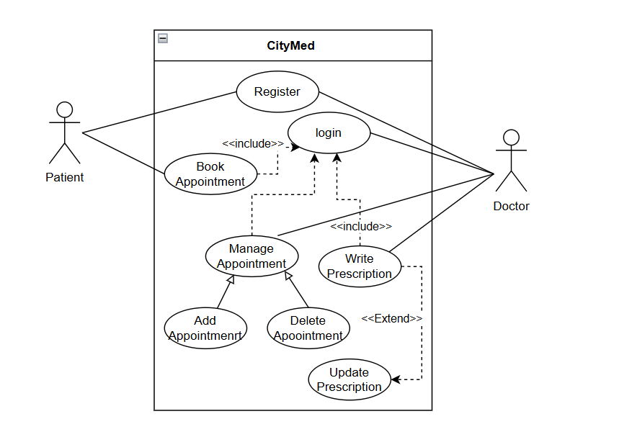.
Fig – Use Case Diagram

Data Flow Diagram
The Data Flow Diagram (DFD) shows how data moves between the Doctor, Patient, the PHP application, and the MySQL database.
Level 0 (Context Diagram): Represents the entire CityMed Hospital Management System as a single process that exchanges data with two external entities: the Doctor and the Patient.
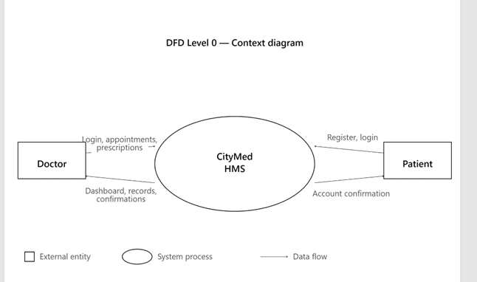
Fig -– Data Flow Diagram (Level 0 – Context Diagram)
Level 1 DFD: Breaks down the system into four main processes — User Authentication, Appointment Management, Prescription Management, and Profile Management — each interacting with the relevant database tables.
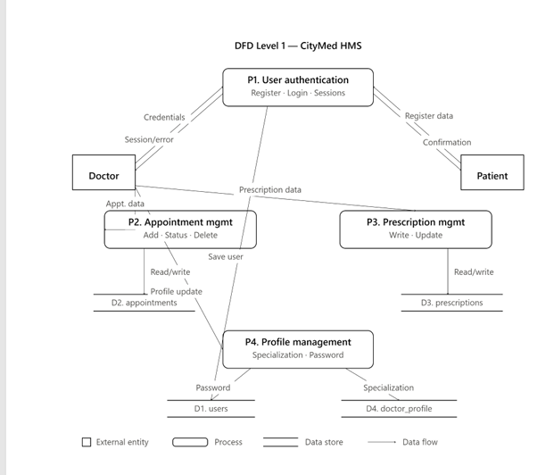
Fig – Data Flow Diagram (Level 1)

SYSTEM IMPLEMENTATION

Development Environment
The CityMed HMS was developed and tested locally using XAMPP, which bundles Apache (web server), MySQL (database), and PHP (backend language) into a single installable package. The code was written using Visual Studio Code, and the application was tested in Google Chrome and Microsoft Edge. All PHP files follow a consistent structure: session handling at the top, database include, business logic, and HTML output at the bottom.

Folder Structure
The project is organized into the following directory structure:
- HospitalManagementSystem – Root project folder.
- index.php – Public hospital landing page.
- css/ – Contains global stylesheets for the website.
- images/ – Stores hero and other static images.
- Pages/ – Contains public pages such as Login, Register, and Main Page.
- DataBaseConnection/ – Contains the database connection file (db.php) and schema.sql.
- DoctorPanel/ – Contains all doctor-related modules and resources.
  - pages/dashboard.php – Appointment management dashboard.
  - pages/prescription.php – Prescription writing module.
  - pages/records.php – Patient records viewer.
  - pages/profile.php – Doctor profile and password management.
  - css/dashboard.css – Styles for all doctor panel pages.
  - db.php – Database connection file for the doctor panel.
  - logout.php – Destroys the session and redirects the user to the login page.

Modules and Features
User Authentication (login.php and register.php)
The Registration page allows users to create a Doctor or Patient account by entering their name, email, phone number, role, and password. The system validates all required fields, checks for a valid email format, and securely hashes the password using PHP's password_hash() with the PASSWORD_BCRYPT algorithm before storing it in the database.
The Login page authenticates users by verifying their email and password. If the credentials are valid, the system creates a secure session, stores the user's information, and redirects them to the appropriate page based on their role.
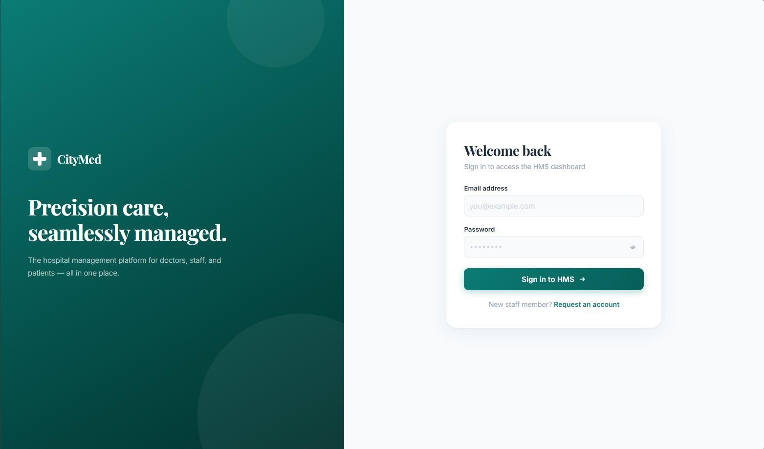
(Figure - Login Page)
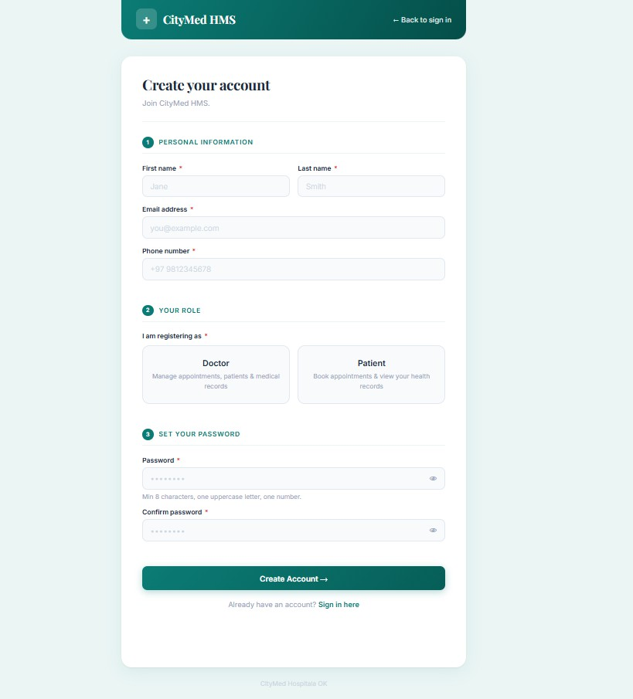
(Figure - Registration page )

Doctor dashboard(dashboard.php)
The Doctor Dashboard serves as the main interface for doctors after login. It displays summary statistics for Total, Scheduled, Completed, and Cancelled appointments, helping doctors quickly monitor their appointments.
The dashboard also includes an Add Appointment form where doctors can enter a patient's name, age, gender, phone number, appointment date, department, and reason for the visit. Once submitted, the appointment is saved in the database and linked to the logged-in doctor.

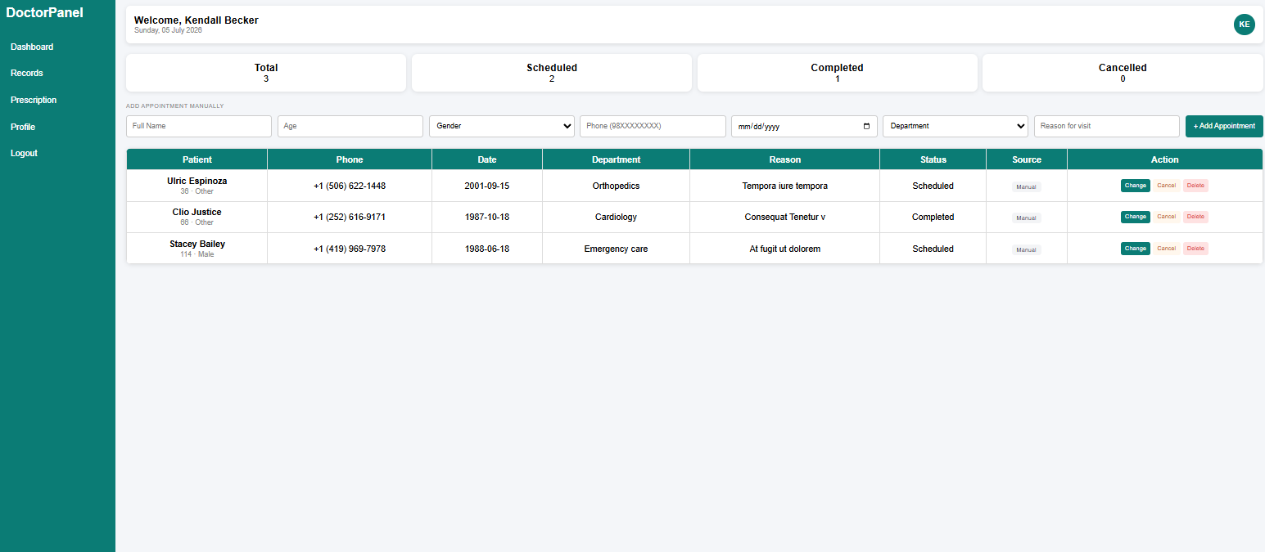
Fig – Doctor Dashboard

Fig – Appintment Manually

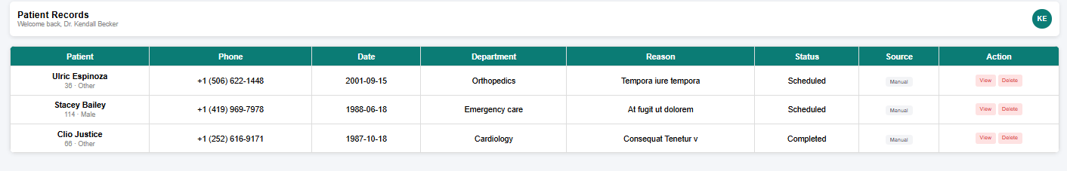
Fig – Appointment table

Prescription Module(prescription.php)
The prescription module allows a doctor to write and save prescriptions linked to a specific appointment. The doctor selects an appointment from a dropdown, which auto-populates the patient name and date. The form then collects the diagnosis, medicines, dosage, duration, and additional notes.
On submission, the module first checks whether a prescription already exists for the selected appointment. If it does, the record is updated using UPDATE; if not, a new record is inserted using INSERT. This upsert logic prevents duplicate prescriptions for the same appointment and allows corrections.
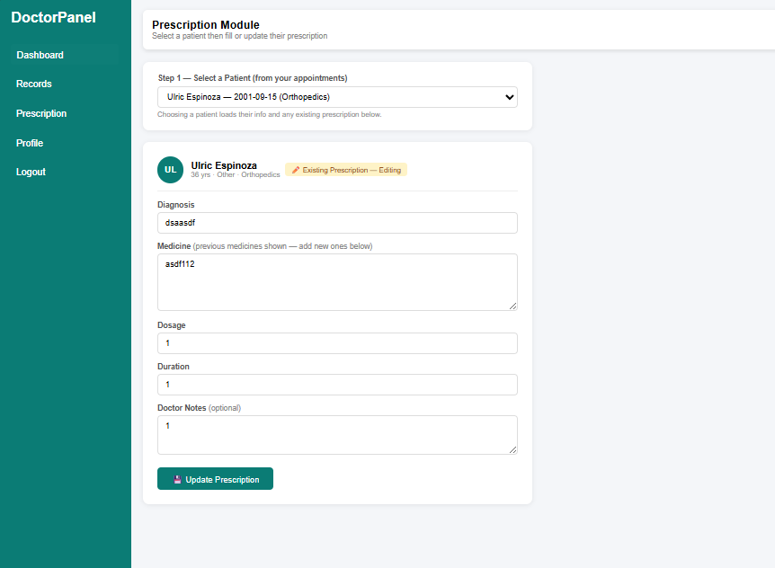
Fig – Prescription module

Patient Records(records.php)
The patient records page provides a read-only view of all patients who have had appointments with the logged-in doctor. It queries the appointments table, listing all patients associated with the doctor's ID along with their contact details and appointment history.

Doctor Profile(profile.php)
The patient records page provides a read-only view of all patients who have had appointments with the logged-in doctor. It queries the appointments table, listing all patients associated with the doctor's ID along with their contact details and appointment history.
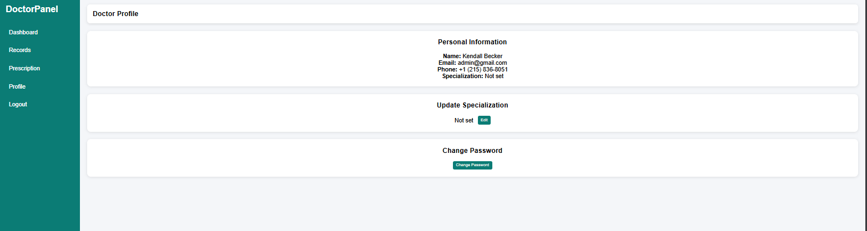
Fig – Profile page

TESTING AND RESULTS

Testing Approach
The system was tested using manual black-box testing, where each feature was tested independently by providing different inputs and verifying the expected outputs. The testing focused on form validation, user authentication, database operations, session management, and overall system functionality to ensure the application worked correctly.
Test Cases
# | Test Case | Input | Expected Output | Result
1 | Register with valid data | All fields filled, role = doctor | Account created, redirect to login | Pass
2 | Register with duplicate email | Existing email address | SQL unique constraint error handled | Pass
3 | Register with weak password | Password < 8 chars | Validation error shown | Pass
4 | Login with correct credentials | Valid email + password | Session set, redirect to dashboard | Pass
5 | Login with wrong password | Valid email, wrong password | Error message, no session | Pass
6 | Add appointment manually | All appointment fields filled | Row inserted, table refreshed | Pass
7 | Change appointment status | Click 'Change' on a Scheduled row | Status cycles to Completed | Pass
8 | Save new prescription | Appointment selected, all fields filled | Record inserted in prescriptions | Pass
9 | Update existing prescription | Re-submit form for same appointment | Record updated, not duplicated | Pass
10 | Change doctor password | Correct current password + new password | Password updated in DB | Pass
11 | Access dashboard without login | Direct URL to dashboard.php | Redirect to login.php | Pass
12 | Logout | Click logout link | Session destroyed, redirect to login | Pass
Table 3.2 – Test Cases and Results

CONCLUSION AND FUTURE RECOMMENDATIONS

Conclusion
The CityMed Hospital Management System successfully demonstrates how PHP, MySQL, HTML, CSS, and JavaScript can be integrated to build a secure and user-friendly hospital management application. The system achieves its main objectives by providing role-based authentication, appointment management, prescription management, patient records, and doctor profile management.
The project also strengthened important software engineering concepts such as relational database design, server-side validation, secure password hashing using bcrypt, and session-based authentication. The separation between the public website and the doctor panel provides a well-organized structure and allows for future enhancements.
Overall, the system serves as a functional hospital management solution that reduces manual record-keeping, improves appointment management, and provides a reliable foundation for future development.

Future Recommendations
- Patient Dashboard: Develop a dedicated patient panel where patients can view appointment history, access prescriptions, and manage their personal information.
- Online Appointment Booking: Allow patients to select a doctor, choose an available appointment date, and book appointments directly through the system.
- Admin Panel: Introduce an administrator module to manage users, approve doctor registrations, monitor hospital activities, and generate reports.
- Email Notifications: Send automated email notifications for appointment confirmations, status updates, and prescription information using PHPMailer or PHP's mail() function.
- Online Payment Integration: Integrate payment gateways such as eSewa or Khalti to enable secure online payment of consultation fees.
- Mobile Responsiveness: Improve the user interface for smartphones and tablets, and consider developing a Progressive Web App (PWA) for easier mobile access.
- Cloud Deployment: Deploy the application on cloud hosting services such as cPanel or AWS so it can be accessed from anywhere without requiring XAMPP.

Appendics and References addd

